*Florida International University*

*School of Computing and Information Sciences*

CIS 4911 - Senior Capstone Project

Software Engineering Focus

Feature Document

User Story # 735

**Team Member:**

Garrett Lemieux

**Product Owner(s)**:

Francisco Ortega

**Mentor(s)**:

Francisco Ortega

**Instructor**: Masoud Sadjadi

**User Story – Add start up image to Application**

* As a user I would like to be informed the name of the application in form of an appealing image in order to enhance my experience with the application.
* **Acceptance Criteria**:
  1. When application begins, start image must appear and fade out after a designated time period.

**Use Case: Start Up Image Displayed when App Started**

User wants to be informed when application begins and name of application.

* Details:
* Actor:
  + User
* Pre-conditions:
  + TouchPoints app is running.
  + Devices connected
* Description:
  + Use case begins when User starts TouchPoints application.
  + User is informed application has started when start up image appears.
  + Use case ends when image has faded out completely.
* Post-conditions:
  + Application is running and waiting for user input.
* Decision Support:
  + Frequency: High, Startup Image will appear every time application begins.
  + Criticality: Low, Nice for user to know when application has started.
  + Risk: Low
* Usability:
  + User only needs to start the application.
  + Image fades out automatically.
* Reliability
  + High
* Performance
  + Performance High
  + Failure Low
* Supportability
  + TouchPointsApp
* Modification History:
  + Owner: Garrett Lemieux
  + Initiation Date 04/18/2016
  + Date last Modified: 05/1/2016

**Use Case Diagram**

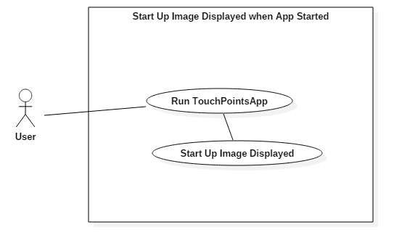

**Sequence Diagram**

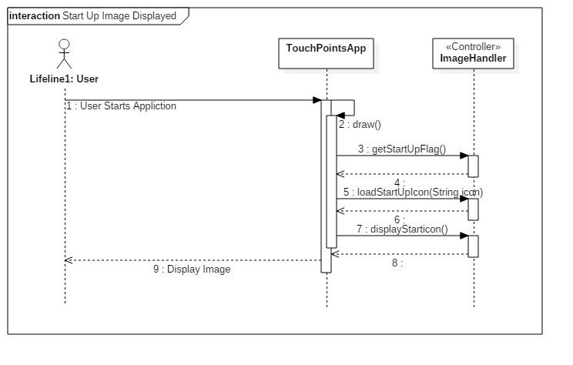

**Class Diagram**

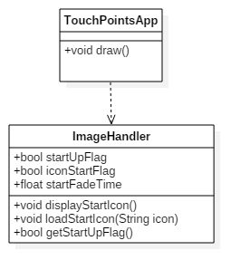

**Unit Test**

* Sunny Day Test:
  + Test Case  - Startup Image is Displayed at Start
    - Test Purpose: To determine if the startup image automatically begins when application is started by user.
    - Test Procedure: User starts application and observes feedback from screen.
    - Expected Results: Application should start up with image being shown in the middle of the canvas. Image should display name of application.
  + Test Case  - Startup Image Fades Out
    - Test Purpose: To determine if the startup image fades out completely after specified amount of time.
    - Test Procedure: User starts application and observes canvas feedback.
    - Expected Results: Application should start up with image being shown in the middle of the canvas. Image should slowly fade out and be completely gone after 5 seconds.
* Rainy Day Test:
  + Test Case  - User accidently Starts Application
    - Test Purpose: To determine if User will be informed application has been started if he or she accidently starts application.
    - Test Procedure: User starts application without knowing application has been start.
    - Expected Results: Application should start up with image being shown in the middle of the canvas and slowly fades out. If user doesn’t see image appear test fails.

**Integration Testing**

* All devices were plugged in and application was started. Startup image appeared and faded out correctly.
* Different combinations of devices were plugged into application and then started. Startup image appeared and faded out.
* After integrating startup image into the application all previous functionality was maintained and functioning correctly.

**User Guide**

* User only needs to start application and wait for startup image to appear.
* The image will fade out on its own after specified amount of time.
* Image on Startup

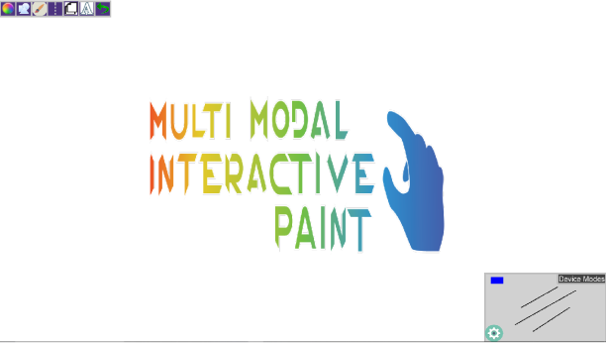

* Canvas after image has faded out.

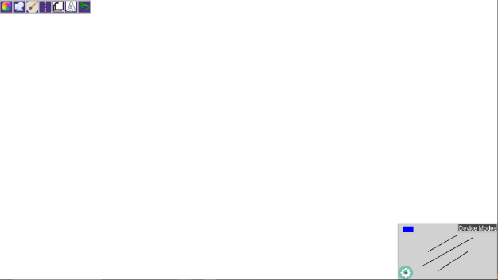

**Glossary**

* Startup Image – Image that is displayed when application is started and fades out after specified amount of time. (Image displays the name of the application)